- What is the definition of statistic ?
Ans . Statistics is the discipline that concerns the collection, organization, analysis, interpretation and presentation of data. In applying statistics to a scientific, industrial, or social problem, it is conventional to begin with a statistical population or a statistical model to be studied.

- What are types of statistics ?
Ans. descriptive and inferential.
Descriptive Statistics : Descriptive Statistics Descriptive statistics are numbers that are used to summarize and describe data.
Inferential Statistics : The sample is a set of data taken from the population to represent the population. Probability distributions, hypothesis testing, correlation testing and regression analysis all fall under the category of inferential statistics.

- What is descriptive statistics ?
Ans. Descriptive Statistics : Descriptive Statistics Descriptive statistics are numbers that are used to summarize and describe data.

- When to use GM , HM, AM?
Ans. Arithmetic mean : represents a number that is achieved by dividing the sum of the values of a set by the number of values in the set. If a₁a₂a₃….,a_{n}, is a number of group of values or the Arithmetic Progression, then;
AM=(a₁+a₂+a₃+….,+a_{n})/n.
- AM: AM(Mean) can be used on a set of observations to arrive at a unanimous result. Mean is usually calculated for normally distributed data
- The arithmetic mean is appropriate when all values in the data sample have the same units of measure, e.g. all numbers are heights, or dollars, or miles, etc.
Ex: conducting a survey to find out the average salary, GDP, per-capita income

Harmonic Mean is defined as the reciprocal of the arithmetic mean of the given data values. It is represented as:
HM = n/(1/a₁,1/a₂,1/a₃,….,1/a_{n})
- HM: HM can be used in problems where were need to find the averages of rates – such as speed, density, any form of ratio

Geometric Mean for a given number of values containing n observations is the nth root of the product of the values.
GM = √(a₁a₂a₃….a_{n})
- GM: GM can be used when the variables under study have multiple characteristics and/or scaled differently from each other.
Ex: comparing the growth of two different organizations, performance of two mobile phones

Relation between GM , HM, AM
AM x HM = GM²

- When to use mean and median ?
Ans. When you have a symmetrical distribution for continuous data, the mean, median, and mode are equal. In this case, analysts tend to use the mean because it includes all of the data in the calculations. However, if you have a skewed distribution, the median is often the best measure of central tendency.

- What is percentile
Ans. A percentile (or a centile) is a measure used in statistics indicating the value below which a given percentage of observations in a group of observations falls.
- For example, the 20th percentile is the value (or score) below which 20% of the observations may be found. Equivalently, 80% of the observations are found above the 20th percentile.
- What is quantiles?
Ans. In statistics and probability quantiles are cut points dividing the range of a probability distribution into continuous intervals with equal probabilities, or dividing the observations in a sample in the same way. There is one fewer quantile than the number of groups created.
- The first Quartile is the middle point of the n scores below the median.
- The Third Quantile is the middle point of the n scores above the median

- What is IQR ?
Ans.
the IQR is the first quartile subtracted from the third quartile; these quartiles can be clearly seen on a box plot on the data. It is a trimmed estimator, defined as the 25% trimmed range, and is a commonly used robust measure of scale.

Data set in a plain-text box plot

+−−−−−+−+
* |−−−−−−−−−−−| | |−−−−−−−−−−−|
+−−−−−+−+

+−−−+−−−+−−−+−−−+−−−+−−−+−−−+−−−+−−−+−−−+−−−+−−−+ number line
0 1 2 3 4 5 6 7 8 9 10 11 12

For the data set in this box plot:
- lower (first) quartile Q₁ = 7
- median (second quartile) Q₂ = 8.5
- upper (third) quartile Q₃ = 9
- interquartile range, IQR = Q₃ - Q₁ = 2
- lower 1.5*IQR whisker = Q₁ - 1.5 * IQR = 7 - 3 = 4. (If there is no data point at 4, then the lowest point greater than 4.)
- upper 1.5*IQR whisker = Q₃ + 1.5 * IQR = 9 + 3 = 12. (If there is no data point at 12, then the highest point less than 12.)

This means the 1.5*IQR whiskers can be uneven in lengths.
The IQR tells how spread out the "middle" values are; it can also be used to tell when some of the other values are "too far" from the central value. These "too far away" points are called "outliers", because they "lie outside" the range in which we expect them.
- Why should you consider 1.5 times of iqr for finding outliers
Ans The difference between Q3 and Q1 is called the Inter-Quartile Range or IQR. ... Well, as you might have guessed, the number (here 1.5, hereinafter scale) clearly controls the sensitivity of the range and hence the decision rule
Refer Link : https://www.khanacademy.org/math/statistics-probability/summarizing-quantitative-data/box-whisker-plots/a/identifying-outliers-iqr-rule
- What is Gaussian distribution
Ans Gaussian distribution (also known as normal distribution) is a bell-shaped curve, and it is assumed that during any measurement values will follow a normal distribution with an equal number of measurements above and below the mean value.

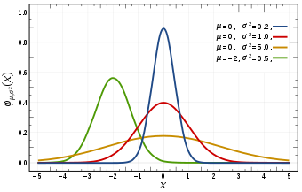

Standard Deviations: SD is a measure of how spread out numbers are (read that page for details on how to calculate it).

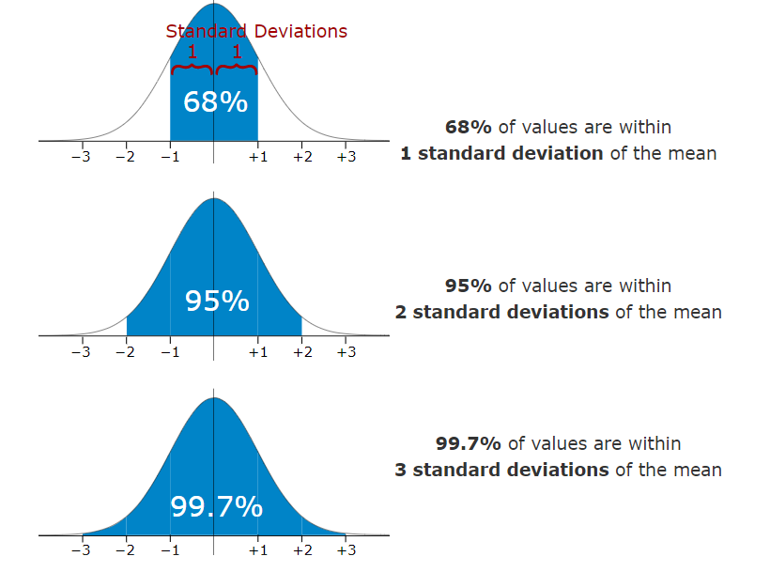

- What is variance ?

ANS. The Average of the squared differences from the mean. It is also used to find the standard deviation.

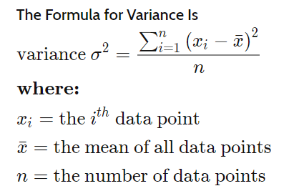

- What is covariance ?
Ans. We use Variance to understand the spread between numbers within a data set.
In probability theory and statistics, covariance is a measure of the joint variability of two random variables. ... In the opposite case, when the greater values of one variable mainly correspond to the lesser values of the other, (i.e., the variables tend to show opposite behaviour), the covariance is negative.
When comparing data samples from different populations, covariance is used to determine how much two random variables vary together, whereas correlation is used to determine when a change in one variable can result in a change in another. Both covariance and correlation measure linear relationships between variables.

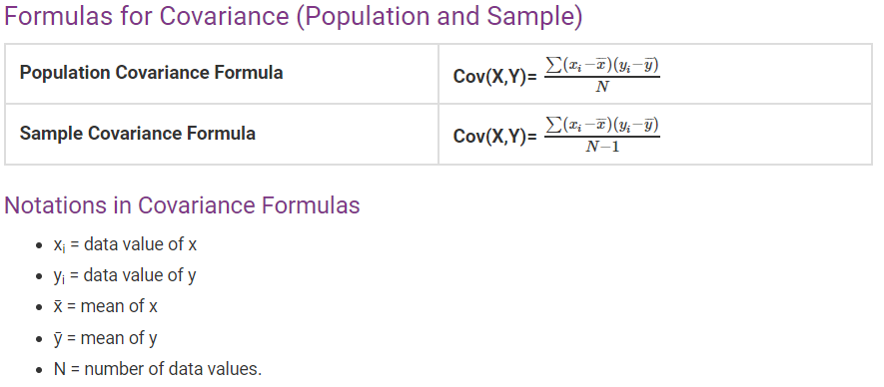

- What are the sampling techniques ?
Ans.
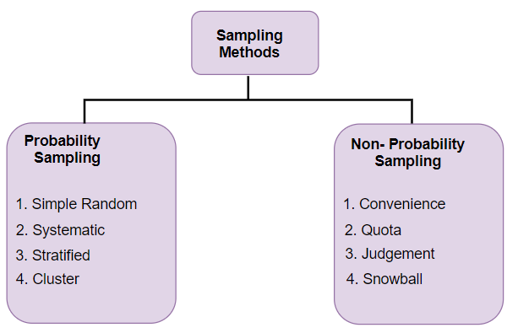

- What is MSE ( assume predicted values is an average)
Ans. The mean squared error tells you how close a regression line is to a set of points. It does this by taking the distances from the points to the regression line (these distances are the “errors”) and squaring them. The squaring is necessary to remove any negative signs. It also gives more weight to larger differences.
A larger MSE means that the data values are dispersed widely around its central moment (mean), and a smalle... ... You usually use MSE to compare different estimators by measuring and comparing the values of the different estimators' MSE values amongst each other
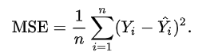

Refer Link : https://www.youtube.com/watch?v=uD1Dfz0aqkA

- What is probability ?
Ans. Probability is the branch of mathematics concerning numerical descriptions of how likely an event is to occur or how likely it is that a proposition is true. Probability is a number between 0 and 1, where, roughly speaking, 0 indicates impossibility and 1 indicates certainty.

- What is discrete & continuous random variable ?
Ans. A discrete variable is a variable whose value is obtained by counting.

Examples:
    - number of students present
    - number of red marbles in a jar
    - number of heads when flipping three coins
    - students’ grade level

A continuous variable is a variable whose value is obtained by measuring.

Examples:
    - height of students in class
    - weight of students in class
    - time it takes to get to school
    - distance travelled between classes

- What is continuous variable ?
Ans. A continuous variable is a variable whose value is obtained by measuring.

Examples:
    - height of students in class
    - weight of students in class
    - time it takes to get to school
    - distance travelled between classes

- What is area under the curve ?
Ans. In Machine Learning, performance measurement is an essential task. So when it comes to a classification problem, we can count on an AUC - ROC Curve. When we need to check or visualize the performance of the multi - class classification problem, we use AUC (Area Under The Curve) ROC (Receiver Operating Characteristics) curve. It is one of the most important evaluation metrics for checking any classification model’s performance.

AUC - ROC curve is a performance measurement for classification problem at various thresholds settings. ROC is a probability curve and AUC represent degree or measure of separability. Higher the AUC, better the model is at predicting 0s as 0s and 1s as 1s.

The ROC curve is plotted with TPR against the FPR where TPR is on y-axis and FPR is on the x-axis.
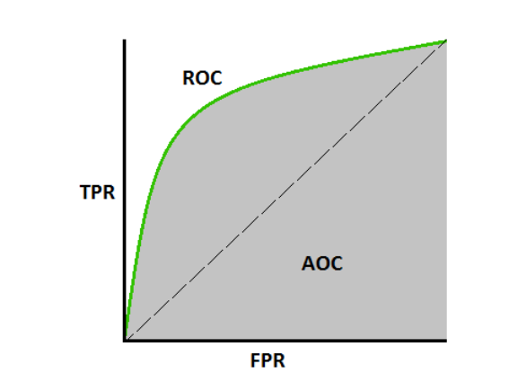

TPR = True Positive Rate
FPR = False Positive Rate
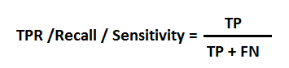
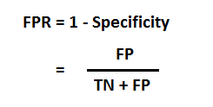
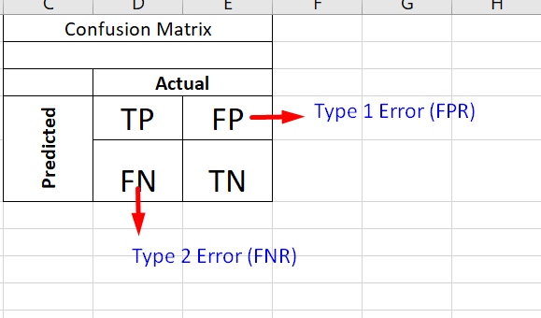

https://www.youtube.com/watch?v=FsC3do74UIo

- What is the necessity for integration in continuous variables ?
Ans. Computationally, to go from discrete to continuous we simply replace sums by integrals. It will help you to keep in mind that (informally) an integral is just a continuous sum.

- What is PMF ?
Ans. In probability and statistics, a probability mass function is a function that gives the probability that a discrete random variable is exactly equal to some value. Sometimes it is also known as the discrete density function

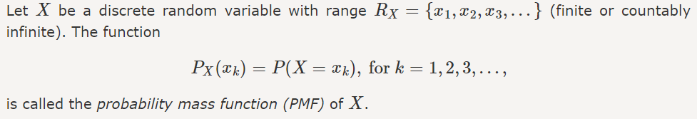

A Probability Mass Function is also termed as a frequency function and is a vital part of statistics. Probability Mass Function integrates that any given variable has the probability that the random number will be equal to that variable. All the probabilities for the given discrete random variables provided by Probability Mass Function. Here discrete essentially means that there are a set number of outcomes for the variables. For understanding discrete variables better, the set number of outcomes in a die can only be 1, 2, 3, 4, 5 or 6. Here a discrete random value when considering a die is a set of random variables which are finite.

- What is probability density function ?
Ans. probability density function (PDF), or density of a continuous random variable, is a function whose value at any given sample (or point) in the sample space (the set of possible values taken by the random variable) can be interpreted as providing a relative likelihood that the value of the random variable would equal that sample.^{[2]} In other words, while the absolute likelihood for a continuous random variable to take on any particular value is 0 (since there are an infinite set of possible values to begin with), the value of the PDF at two different samples can be used to infer, in any particular draw of the random variable, how much more likely it is that the random variable would equal one sample compared to the other sample

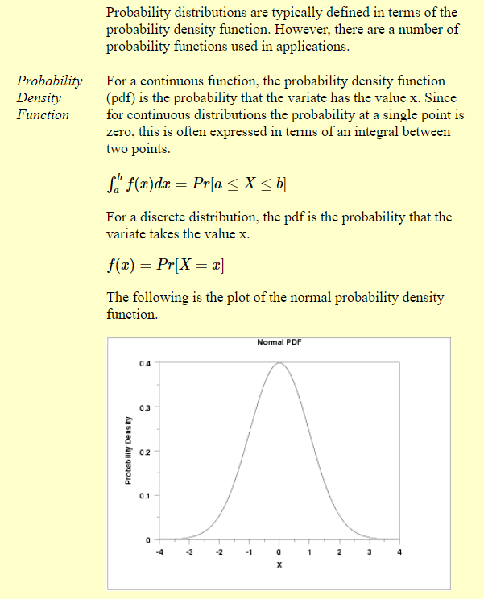
Link : https://www.youtube.com/watch?v=Fvi9A_tEmXQ

- What is cmf ?

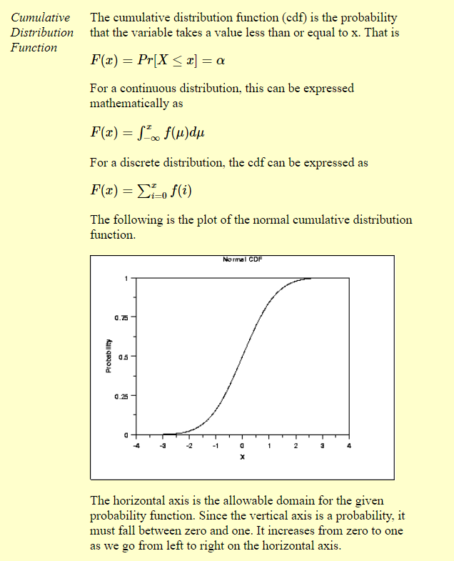

- What is sampling ?
Ans. In statistics, quality assurance, and survey methodology, sampling is the selection of a subset of individuals from within a statistical population to estimate characteristics of the whole population. Statisticians attempt for the samples to represent the population in question.
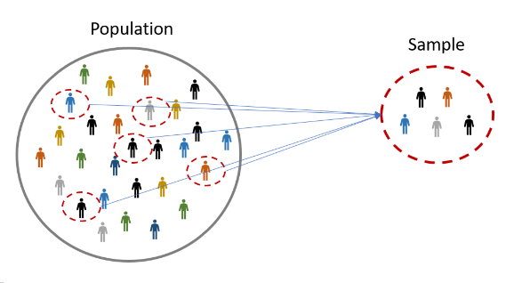

- What is random sampling
Ans. Random sampling is a part of the sampling technique in which each sample has an equal probability of being chosen. A sample chosen randomly is meant to be an unbiased representation of the total population.
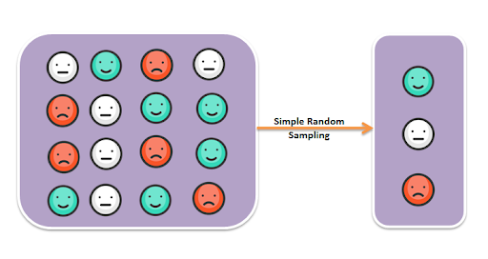

- What is stratified sampling ?
Ans. In statistics, stratified sampling is a method of sampling from a population which can be partitioned into subpopulations. In statistical surveys, when subpopulations within an overall population vary, it could be advantageous to sample each subpopulation independently.
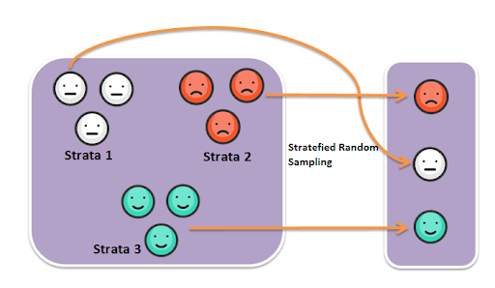

- What are random variables ?
Ans. A random variable is a variable whose value is unknown or a function that assigns values to each of an experiment's outcomes. Random variables are often designated by letters and can be classified as discrete, which are variables that have specific values, or continuous, which are variables that can have any values within a continuous range.

- What is central limit theorem ?
Ans. Given a dataset with unknown distribution (it could be uniform, binomial or completely random), the sample means will approximate the normal distribution.

Sample Size increase, you getting more closer to normal distribution
Larger Sample smaller Standard deviation
Link : https://www.youtube.com/watch?v=JNm3M9cqWyc

- What is coefficient of variation ?
Ans. The coefficient of variation represents the ratio of the standard deviation to the mean,

Example : x=[1,2,3] & y=[101,102,103]
Mean(x)=2 & mean(y)=102
Standard Deviation(x)=1 & Standard Deviation(y)=1

Here the problem is we cannot have SD(y) as 1, because spread of the data is very large and SD(y)=1 is very small.
In-order to over come this we use co-efficient of variation.
We take ratio of the standard deviation to the mean,

CV(X)=1/2=0.5 & CV(Y)=1/102=0.0098
Link : https://www.youtube.com/watch?v=9dwLKGoaeEs

- What is covariance ?
Ans.
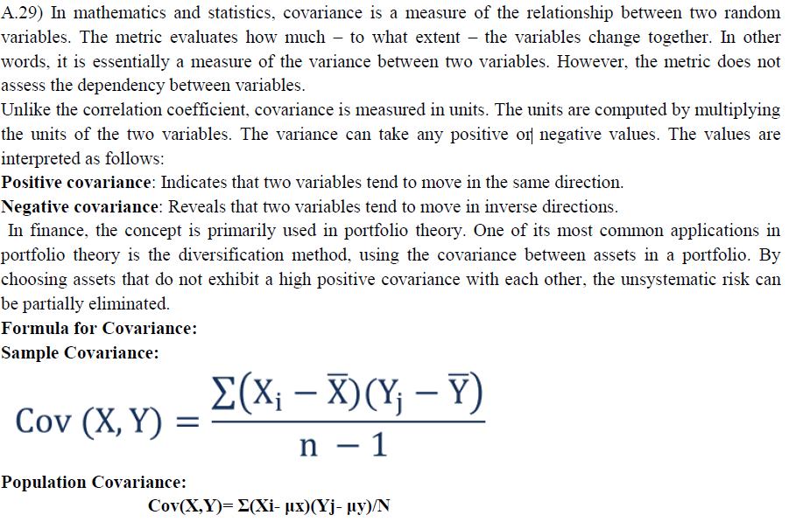

- What is Pearson correlation ?
Ans. Pearson’s Correlation Coefficient helps you find out the relationship between two quantities. It gives you the measure of the strength of association between two variables. Dealing with Quantitative Data.

The value of Correlation will always lie between 1 and -1

- Correlation=0, it means there is absolutely no relationship between the selected feature value and the target value.

- Correlation=1, it means that there is a positive relationship between the selected feature value and the target value and this would mean that the selected feature is appropriate for our model to learn.
- Correlation= -1, it means that there exists a negative relationship between the selected feature value and the target value, generally, the use of the feature value having a negative value of low
magnitude is discouraged for e.g. -0.1 0r -0.2.

Mathematically Pearson’s correlation is calculated as:

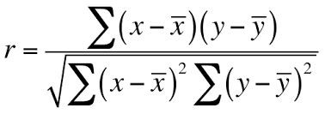

Link : https://www.youtube.com/watch?v=2B_UW-RweSE

- What is spearman rank correlation ?
Ans.
Dealing with Qualitative Data
The Spearman rank correlation coefficient, r_{s}, is the nonparametric version of the Pearson correlation coefficient. Your data must be ordinal, interval or ratio. Spearman’s returns a value from -1 to 1, where:
i). +1 = a perfect positive correlation between ranks
ii). -1 = a perfect negative correlation between ranks
iii). 0 = no correlation between ranks.

Mathematically spearman rank correlation is calculated as:

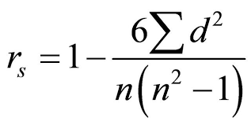

Link : https://www.youtube.com/watch?v=pFzNaxJIpiU

- What is the difference between covariance and correlation ?
Ans. Covariance: It is used to determine how much two random variables vary together and by how
much.
A covariance of ‘0’ indicates the variables are totally unrelated. If covariance is positive the variable
increases in same direction, if negative the variable change in opposite direction.
Correlation: It is used to determine when change in one variable can result a change in another.
Key Differences between Covariance and Correlation

1. A measure used to indicate the extent to which two random variables change in tandem is known
as covariance. A measure used to represent how strongly two random variables are related known as correlation.

2. Covariance is nothing but a measure of correlation. On the contrary, correlation refers to the
scaled form of covariance. Correlation is obtained by dividing the covariance of the two variables
by the product of their standard deviations.
3. The value of correlation takes place between -1 and +1. Conversely, the value of covariance lies
between -∞ and +∞.
4. Covariance is affected by the change in scale, i.e. if all the value of one variable is multiplied by a
constant and all the value of another variable are multiplied, by a similar or different constant,
then the covariance is changed. As against this, correlation is not influenced by the change in
scale.
5. Correlation is dimensionless, i.e. it is a unit-free measure of the relationship between variables.
Unlike covariance, where the value is obtained by the product of the units of the two variables.

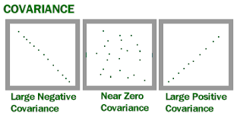
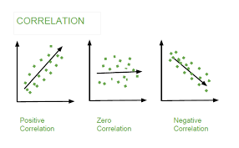
Link : https://www.youtube.com/watch?v=0XKIDqB4Wug

- How to interpret correlation relation ?
Ans. Correlation coefficient is a single number that measures both the strength and direction of the linear relationship between two continuous variables. Values can range from -1 to +1.
Data correlation is the way in which one set of data may correspond to another set. In ML, think of how your features correspond with your output.
For example, the image below visualizes a dataset of brain size versus body size. Notice that as the body size increases, so does the brain size. This is known as a linear correlation. In a simple definition of linear correlation, the data follows a straight line.
Not all data is linearly correlated.
The following image shows a curve of ice cream sales versus temperature. It has an inverted
U-shaped graph. It could mean that if it’s hot enough, people might not want to leave their homes to go buy ice cream. Or there could be another reason.
So using Linear Correlation doesn’t make sense for this dataset.
Not all data is linearly correlated. The following image shows a curve of ice cream sales versus
temperature. It has an inverted U shaped graph . It could mean that if it’s hot enough, people
might not want to leave their homes to go buy ice cream. Or there could be another reason.

So using Linear Correlation doesn’t make sense for this dataset.

Not all data is linearly correlated. The following image shows a curve of ice cream sales versus
temperature. It has an inverted U shaped graph. It could mean that if it’s hot enough, people might not
want to leave their homes to go buy ice cream. Or there could be another reason. So using Linear
Correlation doesn’t make sense for this dataset.

It becomes very hard to figure out how data correlates if you have more than two features. Data
visualization can help find how individual features may correlate with the output.
For example the below figure explains:

Note that if you have a large dataset and if you get a small coefficient, say 0.4, then it’s not necessarily bad. The dataset might have a large statistically significant correlation.
Also note that correlation may not mean causation.
Because two variables are related, does not mean that one directly caused the other. In Titanic dataset, people aboard the Titanic did not die because they were male and aged 28. Rather, a large number of them died because officers were saving “Women and Children First”.

- What is the best way to test a strategy, promotion, campaign ?
Ans.

- What is hypothesis testing ?
Ans. First let us understand what a hypothesis is. A statistical hypothesis is an assumption about a
population parameter. A parameter is a measurable characteristic of a population or a sample, like mean, standard deviation, etc., this assumption may or may not be true.
Hypothesis testing refers to the formal procedures used by statisticians to accept or reject the statistical hypothesis. In simple terms, it is a logical statement which derives True or False. The statement needs to be proven based on the historical data.

The following Hypothesis Testing Procedure is followed to test the assumption made:
1. Set up a Hypothesis
2. Set up a suitable Significance Level
3. Determining a suitable Test Statistic
4. Determining the Critical Region
5. Performing computations
6. Decision-making

- Types of hypothesis testing ?

There are 2 types of hypothesis:
- Null Hypothesis: There is no effect or relationship between the variables. This is denoted by H0.
- Alternative Hypothesis: Effect or relationship exists. This is denoted by H1 or Ha.
We assume that the null hypothesis is correct until we have enough evidence to suggest otherwise.

- For example, suppose we wanted to determine whether a coin was fair and balanced. A null hypothesis might be that half the flips would result in Heads and half, in Tails. The alternative hypothesis might be that the number of Heads and Tails would be very different. Symbolically, these hypotheses would be expressed as
H0: P = 0.5
Ha: P ≠ 0.5

E.g. 36:1
Suppose we flipped the coin 50 times, resulting in 40 Heads and 10 Tails. Given this result, we would be inclined to reject the null hypothesis. We would conclude, based on the evidence, that the coin was
probably not fair and balanced.

Can We Accept the Null Hypothesis?
Some researchers say that a hypothesis test can have one of two outcomes: you accept the null hypothesis, or you reject the null hypothesis. Many statisticians, however, take issue with the notion of "accepting the null hypothesis." Instead, they say: you reject the null hypothesis, or you fail to reject the null hypothesis.
Why the distinction between "acceptance" and "failure to reject?" Acceptance implies that the null hypothesis is true. Failure to reject implies that the data are not sufficiently persuasive for us to prefer the alternative hypothesis over the null hypothesis.
In hypothesis testing there are 2 types of errors:
- Type I: Rejection of a true Null Hypothesis (False Positive). The probability of committing this type of error is called Significance level or alpha. This is denoted by α.
- Type II: Non-Rejection of a false Null Hypothesis (False Negative). The probability of committing this type of error is called beta. This is denoted by β.
One-Tailed and Two-Tailed Tests:
A test of a statistical hypothesis, Where the region of rejection is on only one side of the sampling distribution, is called a one tailed test.
For example, the claim is, Average earning is more than 20$
H0: μ (mean) > 20$
Ha: μ (mean) <= 20$
E.g. 36:2
Here, the region of rejection would consist of a range of numbers located on the right side of
sampling distribution; i.e.; a set of earning greater than 20$. Where the region of rejection is on both sides of the sampling distribution, is called a two-tailed
test. For example, the claim is, Average earning is 20$.
H0: μ (mean) = 20$
Ha: μ (mean) ≠ 20$
E.g. 36:3
Here, the region of rejection would consist of a range of earning located on both sides of the
sampling distribution; i.e.; the region of rejection would consist partly of numbers that were less
than 20$ and partly of numbers that were greater than 20$.
Confusion matrix: Once we are done with model building and deploy this model to Test Data. This
matrix will help us to identify the model accuracy.
Let’s take a scenario where we say customer paid an EMI or not
Size of the confusion matrix depends on how many values we want to predict for example if we want to predict 2 values (customer paid an EMI, Not paid an EMI) hence matrix will be 2*2, or we can say for n values confusion matrix will be n*n

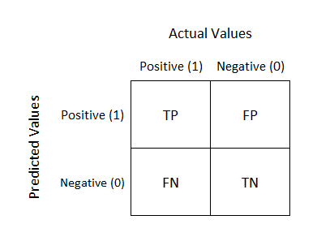

- What is false positive ?
Ans. Where model predicted wrong for positive scenario, other words in actual customer did not paid an EMI but we predicted he has paid.

- What is false negative ?
Ans. Where model predicted wrong for Negative scenario, other words in actual customer paid an EMI but our model predicted he did not.

- What is true positive
Ans. Where our model predicted correct values for Positive scenario, other words in actual customer paid an EMI and our model said yes, he has paid.

- What is true negative ?
Ans. Where our model predicted correct values for Negative scenario, other words in actual customer
did not paid an EMI and our model also said he did not.

This is a list of rates that are often computed from a confusion matrix for a binary classifier:
- Accuracy: Overall, how often is the classifier correct?
o (TP+TN)/total = (100+50)/165 = 0.91
- Misclassification Rate: Overall, how often is it wrong?
o (FP+FN)/total = (10+5)/165 = 0.09 also known as "Error Rate"
- True Positive Rate: When it's actually yes, how often does it predict yes?
o TP/actual yes = 100/105 = 0.95 also known as "Sensitivity" or "Recall"
- False Positive Rate: When it's actually no, how often does it predict yes?
o FP/actual no = 10/60 = 0.17
- True Negative Rate: When it's actually no, how often does it predict no?
o TN/actual no = 50/60 = 0.83 equivalent to 1 minus False Positive Rate also known as "Specificity"
- Precision: When it predicts yes, how often is it correct?
o TP/predicted yes = 100/110 = 0.91
- Prevalence: How often does the yes condition actually occur in our sample?
o actual yes/total = 105/165 = 0.64
- ROC Curve: A Receiver Operator Characteristic (ROC) curve is a graphical plot used to show the diagnostic ability of binary classifiers.
• This is a commonly used graph that summarizes the performance of a classifier over all
possible thresholds. It is generated by plotting the True Positive Rate (y-axis) against the False Positive Rate (x-axis) as you vary the threshold for assigning observations to a given class.

- What is accuracy score ?
Ans. Accuracy is one metric for evaluating classification models. Informally, accuracy is the fraction of predictions our model got right. Accuracy is the most intuitive performance measure and it is simply a ratio of correctly predicted observation to the total observations.
One may think that, if we have high accuracy then our model is best. Yes, accuracy is a great measure but only when you have symmetric datasets where values of false positive and false negatives are almost same. Therefore, you have to look at other parameters to evaluate the performance of your model.
Formally, accuracy has the following definition:
Accuracy = Number of correct predictions/Total number of predictions Classification Accuracy is the number of correct predictions made divided by the total number of predictions made, multiplied by 100 to turn it into a percentage.
For binary classification, accuracy can also be calculated in terms of positives and negatives as follows:
Accuracy=(TP+TN)/(TP+TN+FP+FN)

- What is type 1 error ?
Ans. Hypothesis Testing helps in determining if a specific treatment has the effect on the population.
There are 5 steps involved in any Hypothesis testing.

- State the hypothesis. (both HO – Null Hypothesis and HA – Alternative Hypothesis)
- Set up the suitable significant level i.e. 𝛼 = 0.05 𝑜𝑟 0.01
- Setting a test criterion (i.e. Z-test, t-test, f-test, Chi-square test) Doing computation Making Decision
- During decision making 2 types of error may occurs.
- Hypothesis test depends on sample data, there is a chance of misleading data will cause the
hypothesis test to conclude a wrong answer.
Those 2 types of errors are:
- Type-I error
- Type – II error

Based on our sample if we reject the true null hypothesis then it is called as Type-I error.
When the Null hypothesis is false and we fail to reject this hypothesis, then it is known as Type-II error.
A type 1 error is also known as false positive and occurs when we incorrectly reject a true null hypothesis.
This means that we report that our findings are significant when in fact they have occurred by chance.
The probability of making a type I error is represented by your alpha level (α), which is the p-value below which you reject the null hypothesis. A p-value of 0.05 indicates that you are willing to accept a 5% chance that you are wrong when you reject the null hypothesis. You can reduce your risk of committing a type I error by using a lower value for p. For example, a pvalue of 0.01 would mean there is a 1% chance of committing a Type I error. However, using a lower value for alpha means that you will be less likely to detect a true difference if one really exists (thus risking a type II error).

- Why type 1 error is critical ?
Ans. Type 1 error control is more important than Type 2 error control, because inflating Type 1 errors will very quickly leave you with evidence that is too weak to be convincing support for your hypothesis, while inflating Type 2 errors will do so more slowly.
- A Type I error, on the other hand, is an error in every sense of the word. A conclusion is drawn that the null hypothesis is false when, in fact, it is true. Therefore, Type I errors are generally considered more serious than Type II errors.
- The probability of a Type I error (α) is called the significance level and is set by the experimenter. There is a trade-off between Type I and Type II errors. The more an experimenter protects himself or herself against Type I errors by choosing a low level, the greater the chance of a Type II error.
- Requiring very strong evidence to reject the null hypothesis makes it very unlikely that a true null hypothesis will be rejected. However, it increases the chance that a false null hypothesis will not be rejected, thus lowering power.
- The Type I error rate is almost always set at .05 or at .01, the latter being more conservative since it requires stronger evidence to reject the null hypothesis at the .01 level then at the .05 level

- Why should you perform hypothesis testing ?
Ans. In Data Science, when we try to arrive at a conclusion/solution for problem statement, it is necessary that we make assumptions on the outcomes, which we term as hypothesis –null hypothesis and alternate hypothesis. Through hypothesis testing, we can conclude if the null hypothesis is significant statistically i.e., through repeated tests on different samples and eventually repeated hypothesis testing, we will be able to confirm if a certain hypothesis is significant or not. Also, through repeated tests and repeated hypothesis testing, we can assess the probability of a certain outcome.

- What are variable types ?
Ans. Variable: A variable is any characteristics, number, or quantity that can be measured or counted. A variable may also be called a data item.
Ex: Age, sex, business income and expenses, country of birth, capital expenditure, class grades...etc
Types of variables: Variables can be divided into different types major they are classified into two types 1. Numeric variables
2. Categorical variables

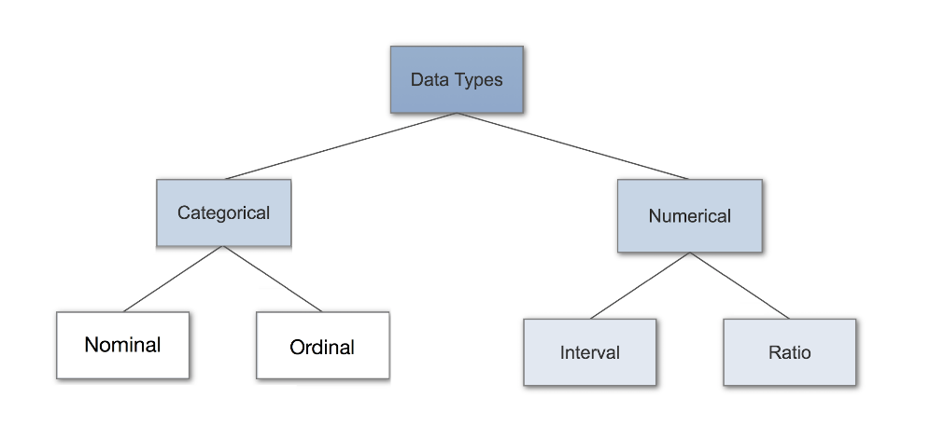
Numeric Variable: Numeric variables have values that describe a measurable quantity as a number.
Therefore, numeric variables are quantitative variables. Numeric variables classified into two types.
i. Discrete
ii. Continuous
i.Discrete variable: A discrete variable cannot take the value of a fraction between one value and the next closest value. It takes only Integer numbers.
Ex: Number of registered cars, number of business locations, and number of children in a family
(i.e.,1,2,3,4...)
ii. Continuous variable: The value given to an observation for a continuous variable can include values as small as the instrument of measurement allows.
Ex: It measured continuous scale like height, weight, time, temperature (i.e., 2.3, 60.5, 3.54...)
Categorical Variable: Categorical variables have place people into groups/categories. Therefore,
categorical variables are qualitative variables and tend to be represented by a non-numeric value.
Categorical variables may be further described as ordinal or nominal:
i. Ordinal
ii. Nominal
i. Ordinal variable: It can be logically ordered or ranked. The categories associated with ordinal variables can be ranked higher or lower than another, but do not necessarily establish a numeric difference between each category.
Ex: Academic grades (i.e. A, B, C), clothing size (i.e. small, medium, large, extra-large) and attitudes (i.e. strongly agree, agree, disagree, and strongly disagree).
ii. Nominal variable: Observations can take a value that is not able to be organized in a logical sequence. Ex: Gender, business type, eye colour, religion and brand.

- What is class variable ?
Ans. Class variables also known as static variables are declared with the static keyword in a class, but outside a method, constructor or a block. When space is allocated for an object in the heap, a slot for each instance variable value is created. The variables that are defined inside the class but outside the method can be accessed within the class (all methods included) using the instance of a class. For Example – self. var_name. If you want to use that variable even outside the class, you must declare that variable as a global.

- What are dummy variables ?
Ans. A dummy variables represents in regression analysis which 1 takes only the value
0 or 1. i.e., to indicate if its presence or absent. Of some categorical effect

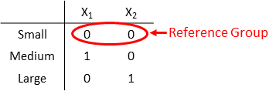

- What is label Encoders ?
Ans. In the Datasets few of the columns contain categorical data (like for the column “Country Name” the values can be as Spain, Germany, India etc). The machine cannot understand categorical data and the data has to be converted to the numerical data. For this Label Encoders is used.The categorical data like Spain, Germany and India is converted to the numerical data as 0, 1, and 2. So in the column “Country Name” the categorical data (Spain, Germany and India) gets
replaced by the numerical data (0, 1 and 2) after encoding. This process is called Label Encoding.
o It is an important pre-processing step for the structured dataset in supervised learning. Label
Encoding is implemented on the training dataset. Label Encoder is a utility class to help
normalize labels such that they contain only values between 0 and n_classes-1 where n is the
number of distinct labels.

- Scikit Learn Pre-processing library is used for encoding in data pre-processing steps.
# Import label encoder
From sklearn import pre-processing
# label_encoder object knows how to understand word labels.
LEncoder=LabelEncoder()
# Encode labels in column
x.iloc[:,0]=lEncoder.fit_transform(x.iloc[:,0])
Disadvantages:
The Machine Learning models are based on the equations so when the Label Encoders are used and each of the categorical values like Spain, Germany, India gets converted to the numerical data 0,1,2. As 2 is greater than 0,1 the equation in the model thinks that India had greater value than Spain and Germany. To overcome this Dummy Variable method is used.

- What is contingency table ?
Ans. Contingency table is essentially a matrix that gives information on the frequency distribution of
variables, usually bivariate or multivariate. The table represents the interrelation between variables. In
python, contingency tables are represented by using the function crosstab.
- Contingency table is a part of Descriptive Statistics. This is also known as cross tabulation or
crosstab or 2-way frequency table. This is used to summarize the relationship between 2 or more categorical variables by presenting the frequency distribution.
- Contingency tables are constructed by listing all the categories of one variable as rows in a table and the categories of the other variables as columns. Contingency table summarizes 3 probability distributions:

1. Joint Distribution
2. Marginal Distribution
3. Conditional Distribution

i. Joint Distribution: This is used to find the relationship between a category of two variables. The cells of the contingency table divided by the total provide the joint distribution.
E.g., the probability that a female person prefers ice cream in a cone is 335 / 2200 ≈ 15.23%.
ii. Marginal Distribution: This describes the distribution of the R (row) or C (column) variable alone. The row and column totals of the contingency table provide the marginal distribution.
E.g., the probability that a person prefers ice cream in a cup is 1002 / 2200 ≈45.54%, while the probability of random female participant is 1000 / 2200 ≈ 45.45%
iii. Conditional Distribution: This describes the distribution of one variable given the category of the other variable. The cells of the contingency table divided by the row or column totals provide the conditional distributions.
E.g., the probability that a person prefers ice cream sandwiches, given that the person is male is 24 / 1200= 2%, while the conditional probability that a person is a male, given that ice cream sandwiches arepreferred is 24/44 ≈ 54.54%
Note: Hypothesis tests on contingency may be performed based on a statistic called chi-square.

- What is linear and nonlinear relation ?
Ans. Linear Relation : A linear relationship (or linear association) is a statistical term used to describe a straight-line relationship between a variable and a constant. Linear relationships can be expressed either in a graphical format where the variable and the constant are connected via a straight line or in a mathematical format where the independent variable is multiplied by the slope coefficient, added by a constant, which determines the dependent variable.
The Linear Equation Is: Mathematically, a linear relationship is one that satisfies the equation:
y=mx+b where: m=slope , b=y-intercept

An equation expressing a linear relationship can't consist of more than two variables, all of the
variables in an equation must be to the first power, and the equation must graph as a straight line.
➢ A linear function in mathematics is one that satisfies the properties of additivity and
homogeneity. Linear functions also observe the superposition principle, which states that the net
output of two or more inputs equals the sum of the outputs of the individual inputs.
➢ A commonly used linear relationship is a correlation, which describes how one variable changes
in a linear fashion to changes in another variable.
Example:
1) A linear relationship can also be found in the equation distance = rate x time.
2) In order to convert Celsius to Fahrenheit
C=5/9(F-32)
Nonlinear relation : Nonlinear relation in equations, such as conic sections, include at least one equation that is nonlinear. A nonlinear equation is defined as an equation possessing at least one term that is raised to a power of 2 or more. When graphed, these equations produce curved lines.
➢ Since at least one function has curvature, it is possible for nonlinear equations to contain multiple
solutions. As with linear equations, substitution can be used to solve nonlinear relation for one
variable and then the other.
➢ Solving nonlinear equations algebraically is similar to doing the same for linear of equations.
However, subtraction of one equation from another can become impractical if the two equations
have different terms, which is more commonly the case in nonlinear systems.
Example:
1>GPS signal
2>Earth orbit rotation
3>Radar signal
Differential view : Linear functions have a constant slope, so nonlinear functions have a slope that varies between points. Algebraically, linear functions are polynomials with highest exponent equal to 1 or of the form y = c where c is constant. Nonlinear functions are all other functions. An example of a nonlinear function is y = x^2.
In real life example, children are often prescribed in proportion to weight. This is an example of a linear relationship where as a drug may be ineffective up until a certain threshold and then become effective is a nonlinear relationship. Linear relation always follows below property but a nonlinear cannot:
a. Additivity: f(x + y) = f(x) + f(y)
b. Homogeneity of degree 1: f(αx) = αf(x) for all α
A linear relation as functions are those who can be brought to the form ‘ f(x) = ax + b ’ and but non-linear equations are those who can not be brought to the for form ‘ax + b = 0 ’.
The graph of a linear equation forms a straight line (all data points make a line as unidirectional), whereas the graph for a non-linear relationship is curved (all data points make a non-uniform line graph in linear relation, we can predict other points based on Y=MX+C, but in nonlinear, it is not predictable.

